Grade 4
Science Fair: Growing Crystals

Description: | Students will:  Make an interactive science book.  Type the text of observations and methods for the science experiment.  Take digital photos, or download images from the internet.  Create scripts to make the illustrations move appropriately.
Project View | 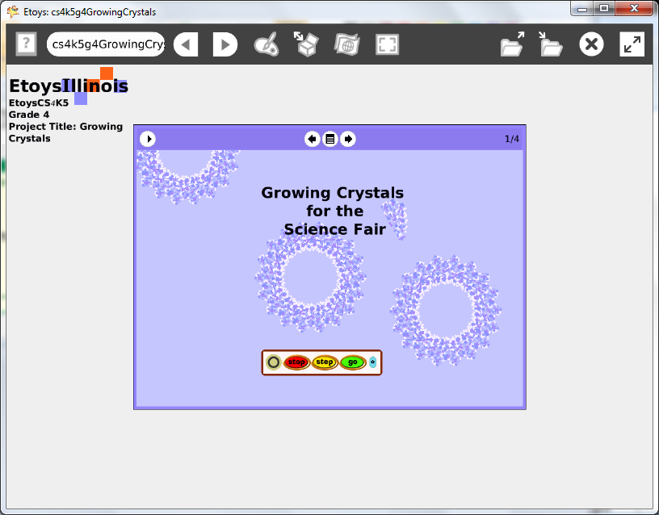
Subject: | Mathematics, Language Arts, Art
Etoys Quick Guides | Click the question mark in Etoys to open the set of interactive tutorials for basic tools and techniques.
Vocabulary: | Observations, methods, experiment, digital images
Lesson 1:  Books: Top Border Icons  Books: Expanded Controls  Supplies: Text  Books: Working with Layers  Supplies: Digital Images  Navigator Bar: Keep Find Project | This book project is designed to give older (4th grade) students a purposeful project and a way to communicate interesting scientific information.  It gives students experience combining ideas from mathematics, science, language arts and programming.  Give students time to revise their pages.  Give students time to read the science books by other students in the class.  All the books do not need to be the same topic. They should be a varied as the science projects undertaken by students.  Use a real book as an example to help students understand the parts of the book, a real book and a virtual one. Proficiency in working with layers takes time to develop.  Fourth grade students should type the text for their book.  Open a book from Supplies and click the left arrow to open more options. Add pages.  Keep the project. Name it: NameCounts e.g. KateScienceBook
Standards: | Common Core Standards  Language Arts: 4.W.2.a.b., 2. 6.; 4..L.1.2  Bloom’s Taxonomy/Cognitive Domain:  Knowledge: knows  Comprehension: gives examples, rewords,  Application: produces, uses, changes  Analysis: analyzes, compares, experiments  Synthesis: categorizes, explains, creates, modifies, plans  Evaluation: compares, reviews  NETS:  1. a, b  2. b  4. a, b  5. a, b, c, d
Resources: | Etoys Help Quick Guides: always available in Etoys. Open Etoys and click the question mark to open a set of interactive tutorials of basic tools and techniques.  www.etoysillinois.org projects, lesson plans, software download  www.mste.Illinois.org more math, science, and technology resources  www.corestandards.org Common Core Standards  www.squeakland.org software and Etoys projects  www.nctm.org Standards and Focal Points for each grade level
kh February 2011

